ISLAM

A Brief Treatise on Islam according to the Qur’an and the Prophetic Sunnah
(A raw version without evidence) ⁽⁾

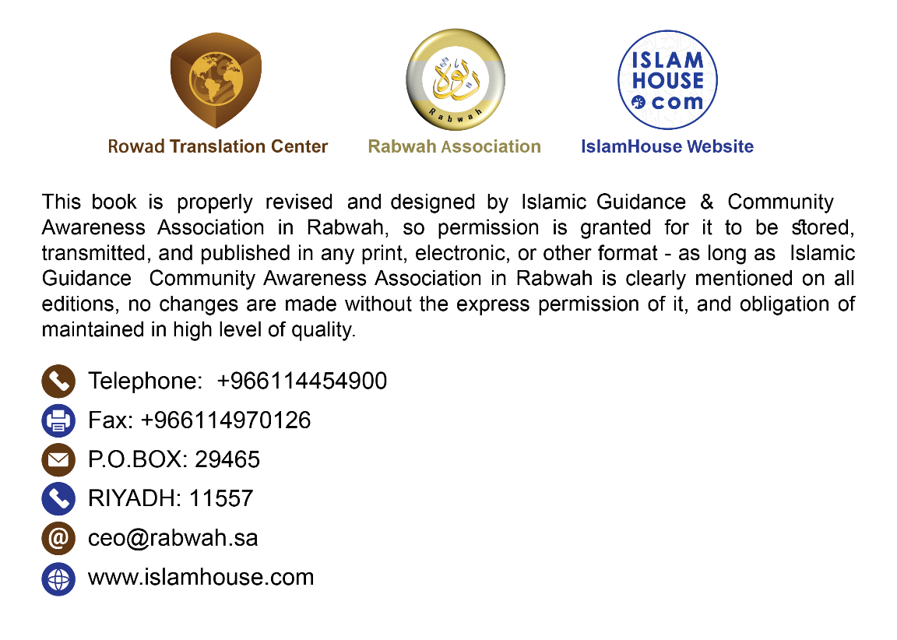

In the name of Allah, the Most Compassionate, the Most Merciful.

This is an important treatise offering a concise introduction to Islam. It illustrates its most essential pillars, teachings, and beauties drawn from its original sources, namely the Noble Qur’an and the Prophetic Sunnah. This treatise is addressed to all legally competent individuals, Muslims and non-Muslims alike, in all of their respective languages, in all times and everywhere regardless of the changing circumstances.
1. Islam is the message of Allah to all people, as it is the eternal divine message.
2. Islam, as a religion, is not exclusively sent to a specific ethnic group, rather it is the religion of Allah to all humans.
3. Islam is the divine message sent to complement all the messages of the previous prophets and messengers (peace be upon them) who were sent to their respective nations.
4. The prophets (peace be upon them) share a single religion though expressed in different laws.
5. Islam, like all the prophets Nūh (Noah), Ibrāhim (Abraham), Mūsa (Moses), Sulaymān (Solomon), Dāwūd (David), and ‘Isa (Jesus) among others, calls to believing that the [true] Lord is Allah, the Creator, the Provider, the One Who gives life and the One Who takes it away, the Owner and Planner of everything, and the All-Kind and the All-Merciful.
6. Allah Almighty is the Creator and the only One worthy of worship without associating anyone else alongside Him.
7. Allah is the Creator of everything in the universe, both the visible and the invisible. Everything other than Him is created by Him. He created the heavens and the earth in six days.
8. Allah Almighty has no partner in His dominion, creation, disposal of affairs, or His right to worship.
9. Allah Almighty begot no one nor was He begotten. None is equivalent or similar to Him.
10. Allah Almighty does not assume any physical form nor is He embodied in any of His creation.
11. Allah Almighty is Kind and Merciful to His servants, therefore, He sent messengers and revealed scriptures.
12. Allah is the Most Merciful Lord. He, alone, will hold His creation accountable on the Day of Judgment when He resurrects them all from their graves. Each individual will be recompensed according to his deeds. Whoever does good deeds while being a believer will enjoy an eternal bliss, whereas anyone who disbelieves and sins will suffer the painful punishment in the Hereafter.
13. Allah Almighty created Adam from dust and made his offspring reproduce after him. So, all people are equal in terms of their origin and there is no superiority for a particular gender over the other or an ethnic group over another except by means of piety.
14. Each newborn is born on Fitrah (a sound natural disposition).
15. No human being is born with an inherent sin nor does he inherit someone else’s sin.
16. The ultimate end of creating mankind is to worship Allah alone.
17. Islam has honored the human being, male and female, and has guaranteed him all of his rights. It has made him responsible for all of his choices, actions, and behavior, thus holding him accountable for any act that harms him or others.
18. Islam made men and women equal in terms of their respective responsibilities, reward, and punishment.
19. Islam has honored women and considered them the counterparts of men. It also mandated financial provision on the man if he is capable. The father is obligated to spend on his daughter, the son on his mother if he is adult and capable, and the husband on his wife.
20. Death is not the ultimate end, rather a transition from the abode of work to the abode of recompense. Death befalls both the body and the soul such that the latter disengages from the body at the time of death, only to return to it following the resurrection on the Day of Judgment. The soul does not move to another body after death nor is it reincarnated in a different body.
21. Islam calls to believing in the most essential pillars of faith: belief in Allah and His angels, the scriptures such as the Torah, the Gospel, the Psalms (before their distortion), and the Qur’an. It also calls to believing in all the prophets and messengers (peace be upon them) and that Muhammad is their seal. Furthermore, Islam calls to believing in the Last Day because assuming this worldly life to be the end makes this life and the whole existence absolutely purposeless. It also calls to believing in destiny and fate.
22. All the prophets (peace be upon them) are infallible in what they convey from Allah and they are protected against committing anything that may contradict reason or violate upright morals. The prophets are tasked with conveying the commands of Allah to His servants. They possess nothing of the qualities of lordship or deity. Instead, they are merely humans to whom Allah Almighty sent His revelation.
23. Islam calls to dedicating the main pillars of worship to Allah alone such as the prayer that involves standing, bowing, prostrating, remembering and praising Allah, and supplicating Him. The prayer is observed five times a day and it removes all differences as the rich and the poor, the boss and the employee, as they all stand in one row in prayer. Another main act of worship is Zakah that involves paying a small portion of money - in accordance with the conditions and the standard measures designated by Allah. The rich are obligated to pay it to the poor among others and it is payable once a year. The third pillar is fasting that involves refraining from all acts that invalidate it throughout the day in Ramadān. It fosters determination and patience in the soul. Lastly, observing Hajj by heading towards the House of Allah in Makkah once in a lifetime for whoever is capable. In Hajj, everyone is equal in standing before Allah Almighty as it removes all differences and affiliations.
24. One of the most unique features of the acts of worship in Islam is that Allah Almighty legislated their manner of performance, times, and conditions and His Messenger (may Allah’s peace and blessings be upon him) conveyed them, thus leaving no room for any human interference in the process, neither by increase nor decrease. All the prophets (peace be upon them) called to these major acts of worship.
25. The Messenger of Islam is Muhammad ibn ‘Abdullah, a descendant of Ismā‘il (Ishmael), son of Ibrāhim (Abraham) (peace be upon them). He was born in 571 AD in Makkah where his mission as a prophet began. He migrated to Madinah and he had never participated in any polytheistic act with his people though he joined them only in noble acts. He enjoyed an upright moral character before he was tasked with the mission, which earned him the title of the Trustworthy. Allah tasked him with the mission at the age of forty and supported him with great miracles, the greatest of which is the Noble Qur’an that is considered the most sublime sign of the prophets and the only remaining sign until today. After Allah completed the religion and the Messenger (may Allah’s peace and blessings be upon him) conveyed it fully, he died at the age of sixty-three and was buried in Madinah. He (may Allah’s peace and blessings be upon him) is the seal of the prophets and messengers. Allah sent him with guidance and the religion of truth to bring people out of the darkness of paganism, disbelief, and ignorance to the light of Tawhīd (monotheism) and faith. Allah bears witness that He sent him to invite people to Allah by His permission.
26. The Shariah of Islam brought by Prophet Muhammad (may Allah’s peace and blessings be upon him) is the seal of the divine messages and laws. It is the Shariah of perfection and reforming people’s religion and worldly affairs. Its priority is protecting people’s religions, lives, properties, minds, and offspring. It abrogates all the previous laws just as all the messages beforehand abrogated one another.
27. Allah Almighty accepts no other religion but Islam that was brought by Prophet Muhammad (may Allah’s peace and blessings be upon him) and whoever embraces a different religion, it will not be accepted from him.
28. The Noble Qur’an is the Book that Allah revealed to His Messenger Muhammad (may Allah’s peace and blessings be upon him). It is the speech of Allah, Lord of the worlds. He challenged with it both the humans and jinn to produce something similar or even a chapter thereof, which is a persisting challenge until today. The Noble Qur’an answers important questions puzzling millions of people. The Noble Qur’an is preserved in the Arabic language in the same format it was first revealed; no letter is omitted from it and it is printed and circulated. It is a great and miraculous Book worthy of reading or reading the translation of its meanings. Likewise, the Sunnah of the Prophet (may Allah’s peace and blessings be upon him) and his teachings and his biography are also preserved and reported through a chain of reliable narrators. It is also printed in the Arabic language spoken by the Messenger of Allah (may Allah’s peace and blessings be upon him) and translated to many other languages. Both the Noble Qur’an and Sunnahh of the Prophet (may Allah’s peace and blessings be upon him) constitute together the sole source of the rulings and legislations of Islam. Islam cannot be taken from the conduct of its followers, rather it should be taken from the divine revelation; namely the Great Qur’an and the Prophetic Sunnah.
29. Islam instructs kindness to parents even if they are non-Muslims and it also instructs good treatment of children.
30. Islam instructs the individual to observe fairness in words and actions even with the enemies.
31. Islam commands kindness to all people and advocates noble morals and virtuous deeds.
32. Islam instructs adopting praiseworthy morals such as honesty, fulfillment of trusts, chastity, modesty, bravery, generosity, aiding the needy, helping the distressed, feeding the hungry, treating neighbors kindly, maintaining kinship ties, and kindness to animals.
33. Islam made good food and drink lawful. It instructs the purification of the heart, the body, and the house, which is why it made marriage lawful. Allah commanded all the prophets (peace be upon them) with those commands as they call to all sorts of good.
34. Islam prohibited the major sins such as polytheism, disbelief, worship idols, attributing something to Allah without knowledge, killing of children or an inviolable soul, causing mischief on earth, sorcery, apparent and hidden indecencies, adultery, sodomy, usury, and eating a dead animal or animals slaughtered for the sake of idols or anything other than Allah. Furthermore, Allah prohibited eating the flesh of swine, all the impurities, consuming the property of an orphan, defrauding in measures and weights, and severing kinship ties. All the prophets (peace be upon them) unanimously agreed on forbidding the above prohibitions.
35. Islam forbids the disgraceful traits such as lying, cheating, betrayal, treason, deception, envy, malicious scheming, theft, transgression, oppression, and all other evil traits.
36. Islam prohibits financial transactions involving usury, harm, deception, oppression, cheating, or causing catastrophic consequences to societies, peoples, and individuals.
37. Islam contains teachings to preserve reason and prohibits what damages it such as consuming intoxicants. Islam elevated the status of reason such that it constitutes the backbone of legal competence. It freed reason from the shackles of mythology and idolatry. Islam has no secrets or rulings that are exclusive to a certain class, rather all of its rulings and laws are consistent with sound reason and comply with justice and wisdom.
38. If the followers of false religions failed to recognize the contradictions and irrational issues therein, the clergy would successfully convince them that religion is above reason as the latter has no role in understanding the religion. Islam, on the other hand, considers religion a light showing reason its path. False religions wish that man would relinquish reason to be their obedient follower, whereas Islam fosters reason so that the individual recognizes the true nature of everything around him.
39. Islam reveres sound knowledge, encourages impartial scientific research, and advocates thinking and pondering on ourselves and the universe around us. The sound scientific results are consistent with the guidelines of Islam.
40. In the Hereafter, Allah only accepts and rewards the deeds of those who believe in Him, obey Him, and believe in His messengers (peace be upon them). Allah does not accept the acts of worship except the ones He legislated. So, how could one hope to secure the reward of Allah while disbelieving in Him? Allah does not accept the faith of anyone except of those who believe in all the prophets (peace be upon them) and in the message of Muhammad (may Allah’s peace and blessings be upon him).
41. The ultimate goal of all the divine messages is to elevate the human being to the level of a sincere servant of Allah, Lord of the worlds, and to free him from servitude to humans, materialism, or mythology. As you can see, Islam does not sanctify people nor does it elevate them beyond their status nor does it take them as deities.
42. Allah legislated repentance in Islam. It is when the individual turns to his Lord and abandons his sin. Just as Islam erases whatever sins existed prior to embracing it, so does repentance. So, it is pointless to admit one’s sins to any human being.
43. In Islam, the relationship between the individual and Allah is direct and needless of intermediaries. Islam prohibits considerubg humans as gods or associates with Allah in His Lordship or in His right to worship.
44. In conclusion, we should remember that people, and the human society in general, given their different times, national allegiances, and countries, are different in their ideologies, goals, environments, and actions. Hence, they needed a guide to lead them, a system to unify them, and a ruler to protect them. The honorable messengers (may Allah’s peace and blessings be upon them) undertook these duties by a revelation from Allah Almighty. They guided people to the path of good and guidance, united them on the Shariah of Allah, and judged with the truth among them. The conditions of people would be reformed depending on the extent of their response to the guidance of those messengers and the proximity of their time to the era of the divine messages. Allah sealed the messages with that of Muhammad (may Allah’s peace and blessings be upon him) and destined it for eternity. Allah has made it a guidance, mercy, and light for people to guide them to Him.
45. Therefore, I call you, O human, to believe in Allah truthfully without the influence of tradition and customs. You must know that you will return to your Lord after your death. You should ponder on your own self and on the horizons around you. Embrace Islam and you shall secure happiness in this worldly life and the Hereafter. If you desire to embrace Islam, all you have to do is to testify that there is no god worthy of worship except Allah and that Muhammad is the Messenger of Allah. You must dissociate yourself from anything worshiped besides Allah and you must believe that Allah is the One to resurrect those in the graves. Also, you must believe that reckoning and recompense are true. Once you utter this testimony, you become a Muslim. The next step is to worship Allah in the manner He prescribed by observing prayer, paying Zakah, fasting, and performing Hajj if you are capable financially and physically.

Dated: 19/11/1441

Written by:
Prof. Muhammad ibn ‘Abdullah al-Suhaym

Former Professor of Creed at the Department of
Islamic Studies
College of Education, King Saud University
Riyadh, Kingdom of Saudi Arabia

الإسلام
نبذة موجزة عن الإسلام كما جاء في القرآن الكريم والسنة النبوية
باللغة الإنجليزية

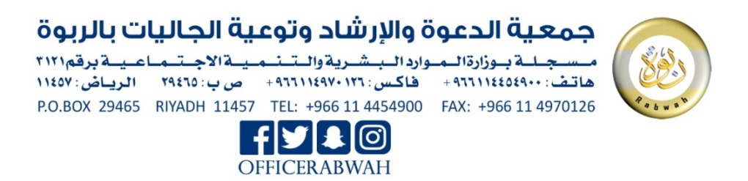
تأليف:
محمد بن عبد الله السحيم

() There is another copy of this treatise tying every issue with its relevant proof from the Noble Qur’an and Sunnah. You can check it on the following link: https://islamhouse.com/en/books/2830465

