# 

# The Six Fundamental Principles

**The author**

**Shaykh al-Islam Muhammad ibn ‘Abdul-Wahhāb**

**(may Allah have mercy upon him)**

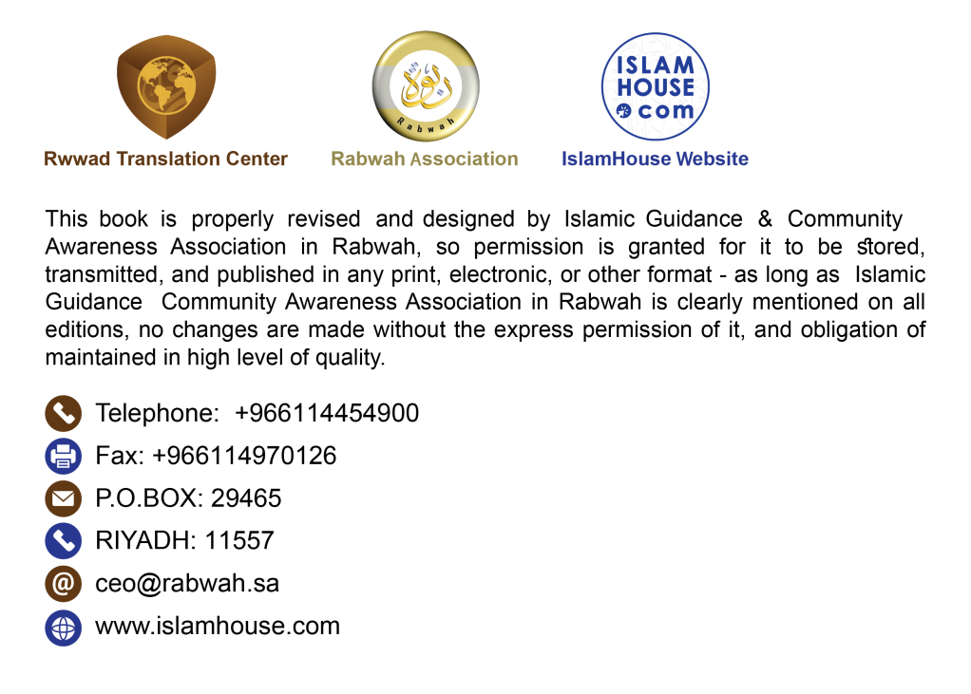

**In the Name of Allah, the Most Compassionate, the Most Merciful.**

Six fundamental principles are among the most wondrous and greatest signs that indicate the omnipotence of Allah, the Overpowering Sovereign. Allah Almighty has made them clear to common people in a way which is above all skeptical assumptions. Nevertheless, many of the intelligent and wise people, save few, have erred with regard to such principles.

## First fundamental principle

Devoting religion sincerely to Allah Almighty alone without associating any partner with Him, and explaining the opposite which is Shirk (polytheism) and pointing out that most of the Qur’an is dedicated to explaining this fundamental principle from various aspects in words that are perceivable by those with the minimum ability of understanding. Then, when the majority of the Muslim Ummah were subject to such known circumstances, the devil presented to them sincere worship under the guise of discrediting the righteous people and falling short in fulfilling their rights, and presented polytheism to them under the guise of loving the righteous and their followers.

## Second fundamental principle

Allah enjoined unity in religion and forbade disunity therein. He explained such principle in the most clear manner that is understandable by common people. He forbade us to be like those who were before us, who were disunited and differed so they were ruined. Allah mentioned that he commanded the Muslims to be united in religion and forbade them from separation therein. This is further clarified by what is reported in the Sunnah, amazingly contributing to its clarification. However, eventually disunity in the fundamental and subsidiary issues of the religion is regarded as knowledge and understanding, while unity in the religion is only upheld by the heretics or mad people.

## Third fundamental principle

Listening to and obeying the ruler, even if an Abyssinian slave, is an aspect of perfect unity in the religion. Allah Almighty adequately explained this in multiple ways, both in terms of the legislation and the divine decree. Then afterwards, this principle became unknown to most of those who claim religious knowledge, let alone acting upon it.

## Fourth fundamental principle

Explaining the meaning of knowledge and who the knowledgeable are, and the meaning of Fiqh (Islamic jurisprudence) and who the jurists are, and defining those who claim to be like them but are not from them. Allah Almighty highlighted this principle at the beginning of Surat al-Baqarah as He said: {O children of Israel, remember My favor that I bestowed upon you, and fulfill My covenant and I will fulfill your covenant.} [Surat al-Baqarah: 40] until His saying: {O Children of Israel, remember My blessing which I bestowed upon you and that I favored you over all other people.} [Surat al-Baqarah: 47]

This is further clarified by what is stated in the Sunnah of abundant manifest lucid statements that anyone with bare mental abilities can grasp. Then it turned to be considered as oddest ideas, as knowledge and Fiqh are regarded as Bid‘ah (innovation in religion) and error, and the best that they have is regarded as truth mixed with falsehood. Those who adopt true knowledge that Allah Almighty has enjoined upon the creation for which they are praised are called as heretics and mad people, whereas those who deny it, antagonize it, and write books warning against and forbidding it are considered the true knowledgeable and well-versed jurists.

## Fifth fundamental principle

Allah Almighty has defined His Awliyā’ (allies/pious slaves) and highlighted the difference between them and those who allegedly claim themselves to be from them from among the hypocrites and wicked people who are Allah’s enemies. The following verse from Surat Āl ‘Imrān is sufficient as a proof of this. Allah Almighty says: {Say, “If you love Allah then follow me; Allah will love you.”} [Surat Āl ‘Imrān:31‏] And a verse in Surat al-Mā’idah that states: {O you who believe, whoever among you renounces his faith, Allah will bring a people whom He loves and who love Him.} [Surat al-Mā’idah: 54]

And a verse in Surat Yūnus that states: {Unquestionably, [for] the allies of Allah there will be no fear concerning them, nor will they grieve.} [Surat Yūnus: 62] Then, to most of those who claim to have knowledge and claim to guide people and guard the Shariah, it is essential for the Awliyā’ to give up following the messengers of Allah, and whoever follows them is not one of the Awliyā’. It is also essential for them to quit Jihād, so the one who observes Jihād is not from the Awliyā’. Moreover, for them abandoning faith and piety is a must and whoever abides by them is not from the Awliyā’. O our Lord, we ask You to grant us pardon and well-being. Indeed, You are the All-Hearer of supplications.

## Sixth fundamental principle

Refuting the misconceptions that the devil has set concerning the abandonment of the Qur’an and Sunnah and following, instead, the disunited and divergent opinions and personal inclinations, alleging that the Qur’an and Sunnah are known only to those who are absolutely qualified to conduct Ijtihād (personal reasoning) i.e. the Mujtahids. They set for the Mujtahid some strict qualities that might not be found completely even in Abu Bakr and ‘Umar. If there is someone who lacks such qualities, then he must turn away from them (the Qur’an and Sunnah) in such a decisive manner that involves neither doubt nor confusion. And whoever seeks guidance from them, then he is either a heretic or a mad person, given the fact that they are too difficult to understand. So glorified is Allah, and praise is due to Him! How much explanation He provided in refuting this cursed misconception, both legislatively and by way of divine decree, and by His creative ability and His legislative command, and from several aspects that amounted to be from the general indisputable facts of the religion, yet most of the people do not know. {The decree [of punishment] has been passed against most of them, for they will not believe. [It is as if] We have placed shackles around their necks up to their chins, so their heads are forced to remain up, and We have placed a barrier before them and a barrier behind them, and have blocked their vision so they cannot see. It is the same to them whether you warn them or not, they will not believe. You can only warn one who follows the Reminder and fears the Most Compassionate unseen. So give him glad tidings of forgiveness and a generous reward.} [Surat Yasīn: 7-11]

All praise is due to Allah, the Lord of the worlds. May Allah’s abundant peace and blessings be upon our Prophet Muhammad, his family and his Companions until the Day of Judgment.

The Six Fundamental Principles 1

First fundamental principle 1

Second fundamental principle 3

Third fundamental principle 3

Fourth fundamental principle 4

Fifth fundamental principle 4

Sixth fundamental principle 5

**كتاب**

**الأصول الستة**

**باللغة الإنجليزية**

**تأليف الإمام**

**محمد بن عبد الوهاب**

